|  |
| --- |
|  |

StrEmbed-3 Users' Manual

Embedding design structures in engineering information

Hau Hing Chau

31 January 2017

Version 3B

What is StrEmbed-3?

Structure Embedding version 3 (StrEmbed-3) is a deliverable from the Embedding Design Structures in Engineering Information project, a Design The Future project funded by Engineering and Physical Sciences Research Council (grant reference EP/N005694/1).

Engineers use design structures, such as Bills of Materials (BoMs), to tailor product definitions, including shape, for particular activities. For example, an engineering BoM defines the as-designed product whereas a manufacturing BoM defines the as-built state of the same product and a service BoM includes information on how the product has been maintained. All of these BoMs relate to the same designed product. However in practice, because of restrictions arising from current computer aided design technologies and associated business systems, different BoMs are usually related to separate digital definitions of the same product. This creates significant data management problems that add cost, time and rework into product development processes. If resolved, substantial business benefits, through improved efficiency and effectiveness of product development processes, could be achieved.

StrEmbed-3 demonstrates how a design structure, for example “as designed”, typically using a computer aided design (CAD) system can be embedded on to a corresponding hypercube lattice. This embedding relationship can be shown visually with this software. Any combinations or permutations of an alternative design structure is also embedded in this hypercube lattice. Modified design structure can be exported to a data format that can be read by a CAD system. A lattice is a partially ordered set (poset) which is equivalent to a corresponding universal algebra. This algebra has a number of useful mathematical properties that allow generation of alternative design structures for other stages of product life cycle, *inter alia*, “as manufactured” and “as maintained”.

Installation

Operating system

StrEmbed-3, in principle™, could be run on any 64-bit operating system. It is tested on Microsoft Windows 7 for x64-based systems, and Debian GNU Linux version 6.0 Squeeze amd64 port. If you use another operating system and have difficulty running StrEmbed-3, please contact the author.

Perl 5 scripting language

StrEmbed-3 is written in Perl 5. It works on Perl version 5.002 or later, but it is not compatible with Perl 6 which has an entirely different code base.

Perl modules

StrEmbed-3 uses a number of Perl [library] modules. There are required on the top of a Perl 5 base installation. They are listed below.

|  |  |  |
| --- | --- | --- |
| Module name | Package name | Description |
| Tk | Tk | Tk – a Graphical User Interface Toolkit |
| Tk::FileDialog | Tk-FileDialog | A highly configurable File Dialog widget for Perl/Tk |
| Set::Partition | Set-Partition | Enumerate all arrangements of a set in fixed subsets |

Installing Perl 5 and its modules on Windows

**Perl 5** – There are many flavours of Perl. Here we provide an example of installing ActivePerl <<http://www.activestate.com/activeperl/downloads>> on Windows. Perl 5 can be obtained from the following. Do follow vendor’s on-screen instructions.

Windows Installer (EXE) for ActivePerl version 5.24.0.2400 for Windows (64-bit, x64)

<http://www.activestate.com/activeperl/downloads/thank-you?dl=http://downloads.activestate.com/ActivePerl/releases/5.24.0.2400/ActivePerl-5.24.0.2400-MSWin32-x64-300558.exe>

**Perl modules** – ActivelyPerl provides a graphical Perl Package Manager.

1/ Entry package name(s) in the search box.

2/ Click “Mark for install [+]”. This button is located at the right hand side of the search box.

3/ Select all required Perl modules listed in the above table.

4/ Click “Run marked actions [Ctrl-Enter]”.

5/ Installation will take 5-10 minutes. Check “Status” window for further instructions, if necessary.

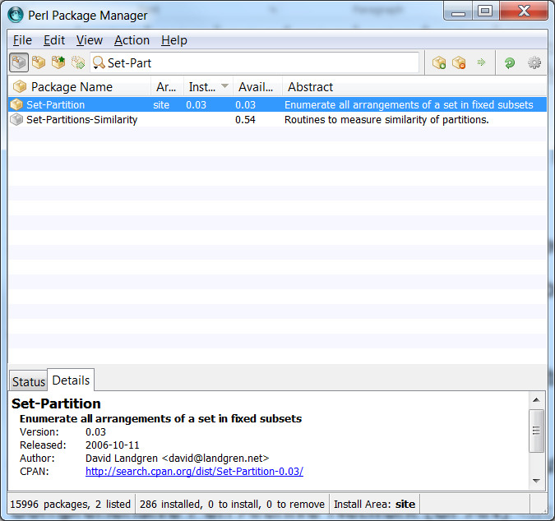

Other flavours of Perl 5 on other operation systems

Comprehensive Perl Archive Network (CPAN) <<https://www.perl.org/cpan.html>> provides Perl for a large number of computing platforms. Perl modules are organised using a command line perl package manager (ppm). There is a little learning curve for it. Nonetheless, all necessary instructions are available from CPAN.

Strawberry Perl <<http://strawberryperl.com/>> is another popular flavour of Perl. One also requires to use command line ppm to manage Perl modules.

Running StrEmbed-3

In a Windows Explorer, double click StrEmbed-3.pl Alternatively, at a Windows command prompt (cmd.exe), type perl StrEmbed-3.pl

On a Unix (including Linux, Mac OSX and macOS), at a console, type chmod a+x StrEmbed-3.pl and follow by ./StrEmbed-3.pl

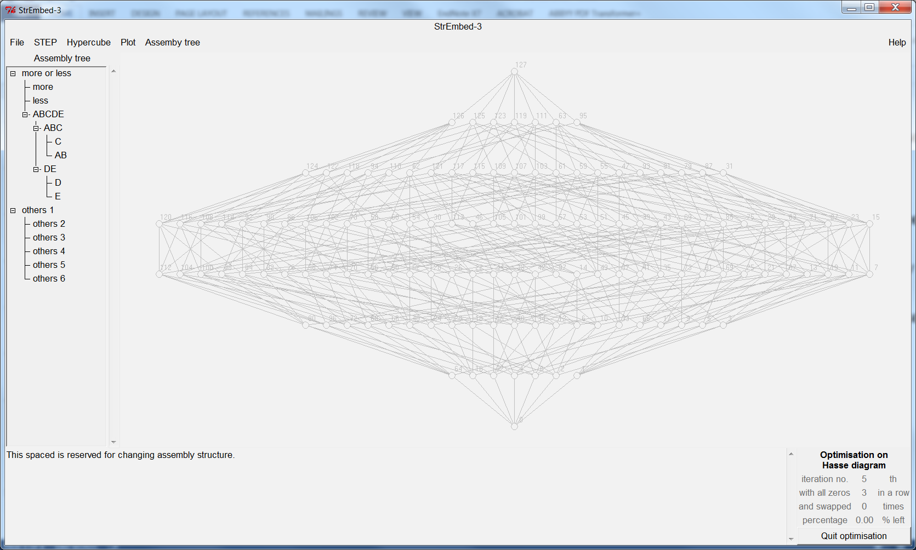Strawberry Perl <<http://strawberryperl.com/>> is another popular flavour of Perl. One also requires to use command line ppm to manage Perl modules.

Walk through examples

SolidWorks assembly to a STEP file

1/ Create an assembly in SolidWorks with up to five parts.

2/ Export the assembly to a STEP AP214 file by File → Save As…, in Save as type: box select STEP AP214 (*.step;*.stp), and then click Save button.

Starting StrEmbed-3 and read STEP file

3/ Click Open and then select puzzle_1b or puzzle_1c or puzzle_1d.

4/ Assembly tree is displayed on the left.

5/ A lattice representing the same assembly structure is displayed on the right, showing it is embedded onto a 25 hypercube lattice.

6/ This background gray out hypercube lattice could be toggled on or off by selecting options under Background 2^n lattice on the menu bar.

7/ To pause optimisation, click Quit optimisation button at the lower right corner. You might need to click it twice.

8/ To resume optimisation, click Plot → Resume optimisation

Change product structure

9/ Select a part or subassembly under the Create new assembly structure heading.

10/ Click SELECT parts and/or sub-assemblies button to confirm the highlighted selection.

11/ A confirmation message will be shown at the message window at the bottom.

10/ File → Open and then select the above STEP file produced by SolidWorks.

11/ Known issue: The present version does not propagate changes to the assembly tree nor the Hasse diagram.

12/ Repeat steps 9/ and 10/ at least once, so that a new sub-assembly will consist or at least two parts and/or subassemblies.

13/ Click CREATE a new sub- (or top level) assembly to create a new subassembly using the previously selected parts.

14/ Repeat step 13/ (which includes step 9/ and 10/) until all parts are exhausted. When that happens, an All done message is shown at the bottom.

Save a STEP AP214 file with the new product structure

15/ Click Save → Save STEP file to save a new STEP AP214 file that consists of the modified assembly structure.

then select the above STEP file produced by SolidWorks.

Open the new created STEP AP214 with SolidWorks or another CAD system

16/ The newly created STEP file is located at ./step_data/output/ with a filename of last input top level assembly name, e.g. assy_3.step

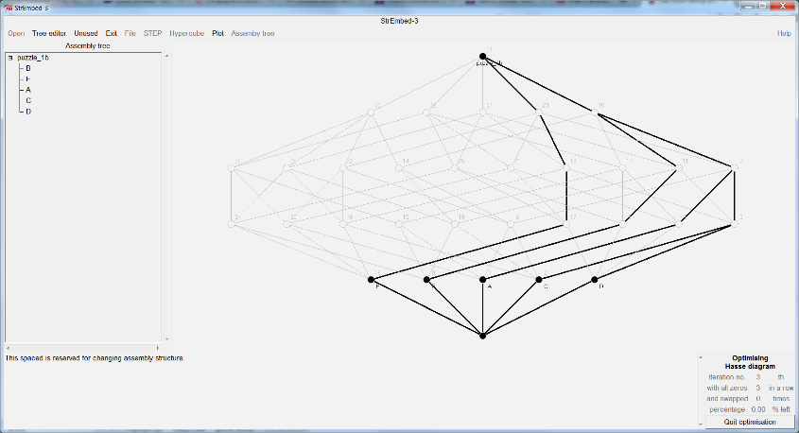Example screenshots

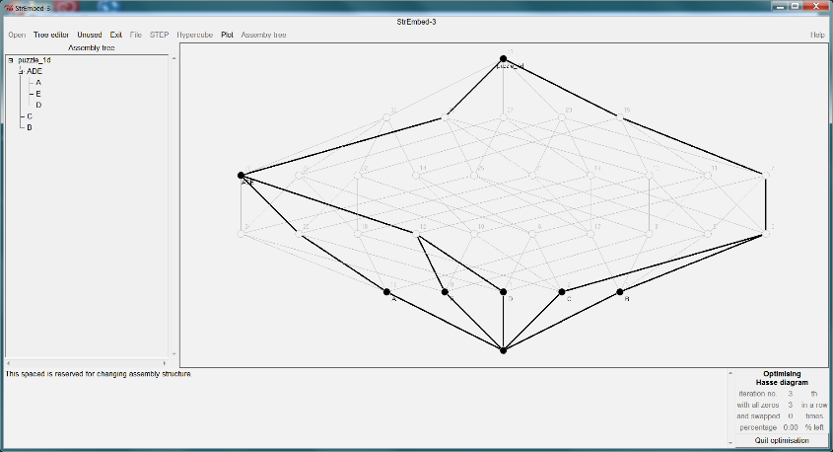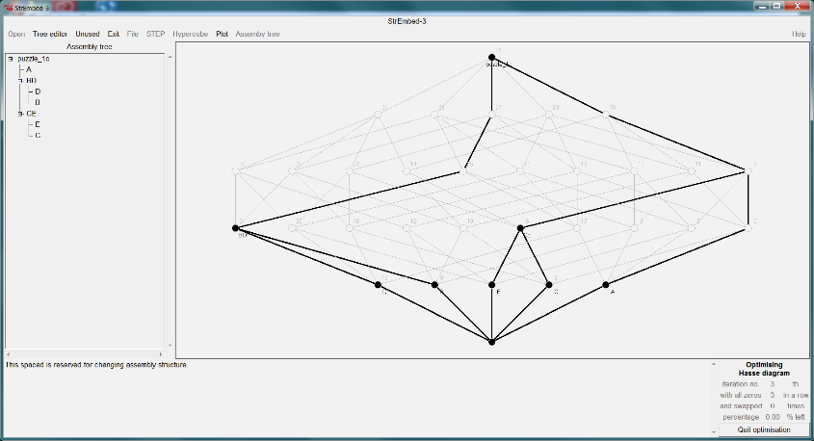

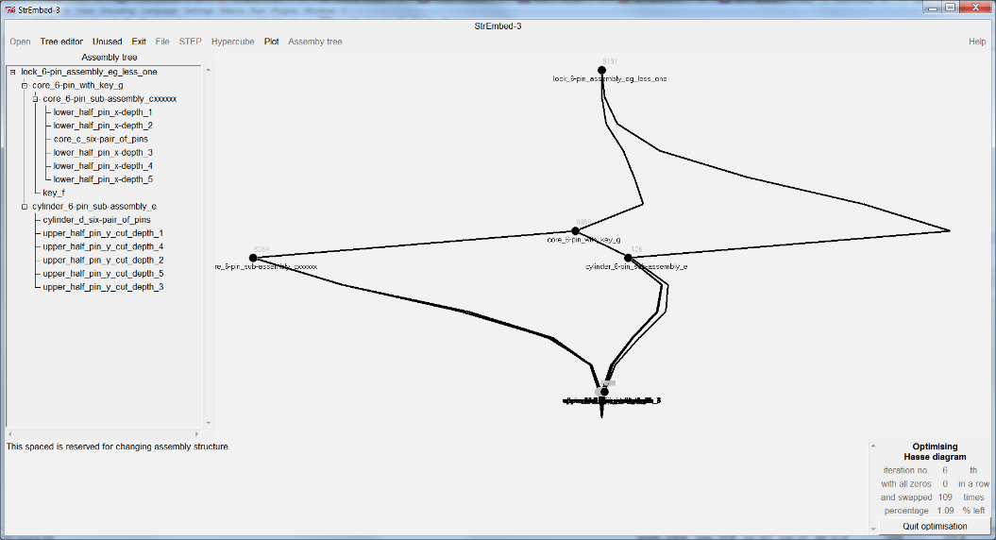

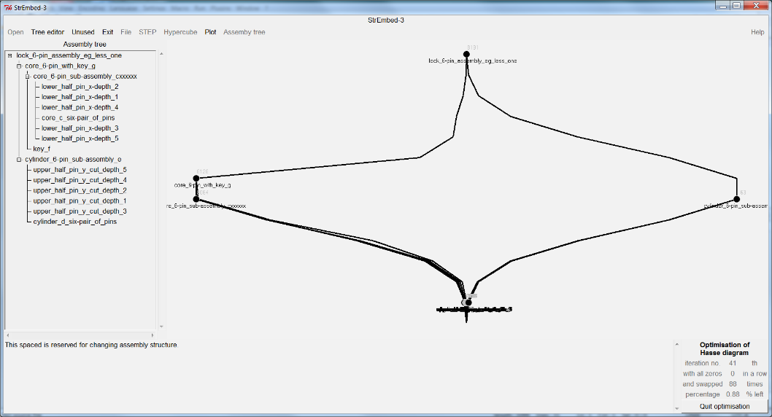

Known bugs

1/ StrEmbed-3 does not support sub-assembly with a single part. If that happens, a sub-assembly[ies] and its part will collapse into one single part silently without warning.

2/ StrEmbed-3 supports assembly with up to nine parts, corresponding and appropriate sub-assemblies, and one top level assembly.

3/ Importing and exporting of STEP AP214 was tested on SolidWorks 2015. In principle™, these functions should work correctly on other CAD systems. Please report any problems to the author. We use STEP AP214 (ISO 10303-214:2010), and aware that it was superseded by ISO 10303-242:2014. We do not expect any practical difference within the limited scope of application protocol AP214 that we used. If you believe the contrary, we would like to hear from you.

4/ StrEmbed-3 is a proof-of-concept prototype. It does its job well when one goes by the script. However, it does not handle exceptions well nor has anywhere near enough useful error messages.

5a/ Note: StrEmbed-3 has a modular design and is meant to be reused. Different modules have minimal interactions. The three modules are (i) for **lattices** and posets, especially producing lattice representation conforms to LatDraw <<http://latdraw.org/>> by Ralph Freese from the University of Hawaii, and also among other things calculating meets and joins, (ii) for importing, interpreting and exporting **STEP** AP214 files; and (iii) for a graphical user interface (**gui**) using Perl/Tk.

5b/ More note: StrEmbed-3 is released under GNU GPL. Therefore, you can incorporate it in your own work as long as you give appropriate acknowledgements, make your source code available for others; and do not incorporate it into proprietary applications without seeking further permission from us.

People

The Design Structures in Engineering Information (Embedding) project is jointly hosted by the University of Leeds and The Open University. Members of the Embedding project are Amar Behera, Hau Hing Chau, Chris Earl, David Hogg, Alison McKay, Alan de Pennington and Mark Robinson.

Getting help and reporting bugs

Send help request and bug report to Hau Hing Chau <[H.H.Chau@leeds.ac.uk](mailto:H.H.Chau@leeds.ac.uk?subject=StrEmbed-3%20help%20request%20and/or%20bug%20report)> School of Mechanical Engineering, University of Leeds, Leeds, LS2 9JT, UK.